**Hands-on Lab: Joins in MySQL using phpMyAdmin**

**Estimated time needed:** 20 minutes

In this lab, you will learn how to create tables and load data in the MySQL database service using the phpMyAdmin graphical user interface (GUI) tool.

**Software Used in this Lab**

In this lab, you will use [MySQL](https://www.mysql.com/?utm_medium=Exinfluencer&utm_source=Exinfluencer&utm_content=000026UJ&utm_term=10006555&utm_id=NA-SkillsNetwork-Channel-SkillsNetworkCoursesIBMDB0110ENSkillsNetwork24601058-2021-01-01). MySQL is a Relational Database Management System (RDBMS) designed to efficiently store, manipulate, and retrieve data.

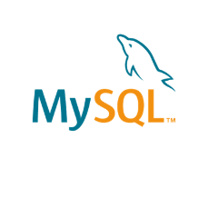

To complete this lab you will utilize MySQL relational database service available as part of IBM Skills Network Labs (SN Labs) Cloud IDE. SN Labs is a virtual lab environment used in this course.

**Objectives**

After completing this lab, you will be able to:

1. Determine the correct type of join to use for a given problem.
2. Write and execute joins to query data from multiple tables.

# Database Used in this Lab

**Mysql_learners** database has been used in this lab.

Here you will be creating and inserting data into the below mentioned 3 tables

1.chicago_public_schools  
2.chicago_socioeconomic_data  
3.chicago_crime

Here you will be using 3 dump files for this purpose.

[chicago_public_schools](https://cf-courses-data.s3.us.cloud-object-storage.appdomain.cloud/IBMDeveloperSkillsNetwork-DB0201EN-SkillsNetwork/labs/MySQL/week5/chicago_public_schools.sql?utm_medium=Exinfluencer&utm_source=Exinfluencer&utm_content=000026UJ&utm_term=10006555&utm_id=NA-SkillsNetwork-Channel-SkillsNetworkCoursesIBMDeveloperSkillsNetworkDB0201ENSkillsNetwork20127838-2021-01-01)

[chicago_crime](https://cf-courses-data.s3.us.cloud-object-storage.appdomain.cloud/IBMDeveloperSkillsNetwork-DB0201EN-SkillsNetwork/labs/MySQL/week5/chicago_crime.sql?utm_medium=Exinfluencer&utm_source=Exinfluencer&utm_content=000026UJ&utm_term=10006555&utm_id=NA-SkillsNetwork-Channel-SkillsNetworkCoursesIBMDeveloperSkillsNetworkDB0201ENSkillsNetwork20127838-2021-01-01)

[chicago_socioeconomic_data](https://cf-courses-data.s3.us.cloud-object-storage.appdomain.cloud/IBMDeveloperSkillsNetwork-DB0201EN-SkillsNetwork/labs/MySQL/week5/chicago_socioeconomic_data.sql?utm_medium=Exinfluencer&utm_source=Exinfluencer&utm_content=000026UJ&utm_term=10006555&utm_id=NA-SkillsNetwork-Channel-SkillsNetworkCoursesIBMDeveloperSkillsNetworkDB0201ENSkillsNetwork20127838-2021-01-01)

**Task A: Create a database**

1. Click on **Skills Network Toolbox**. In **Database** section, click **MySQL**.

To start the MySQL click **Start**.

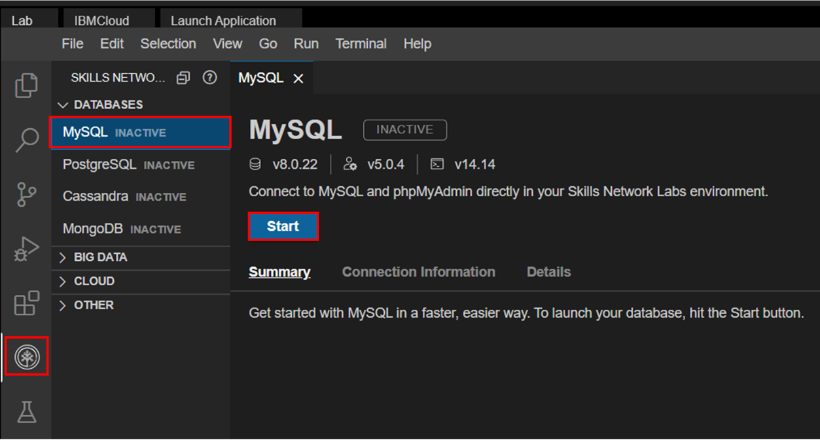

1. Once **MySQL** has started, click on **phpMyAdmin button** to open **phpMyAdmin** in the same window.

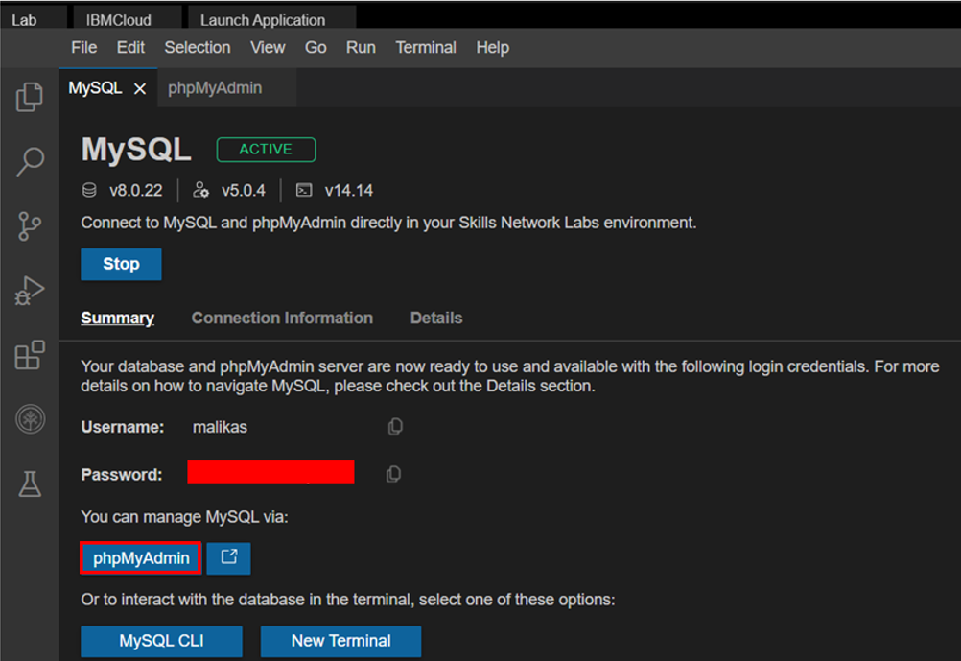

1. You will see the phpMyAdmin GUI tool.

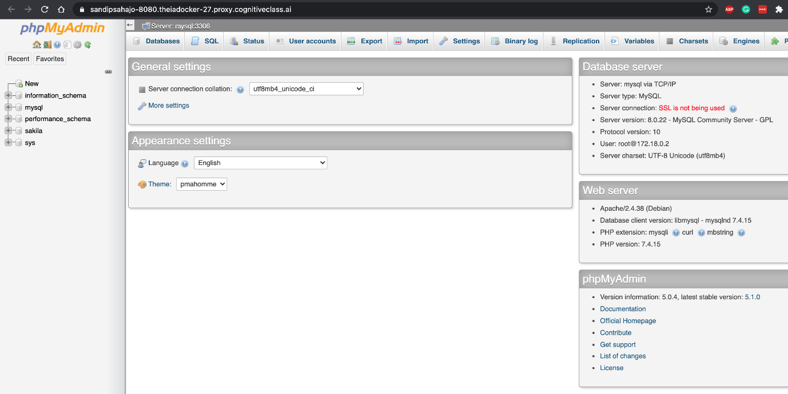

1. In the tree-view, click **New** to create a new empty database. Then enter **Mysql_Learners** as the name of the database and click **Create**.

The encoding will be left as **utf8mb4_0900_ai_ci**. UTF-8 is the most commonly used character encoding for content or data.

Proceed to Task B.

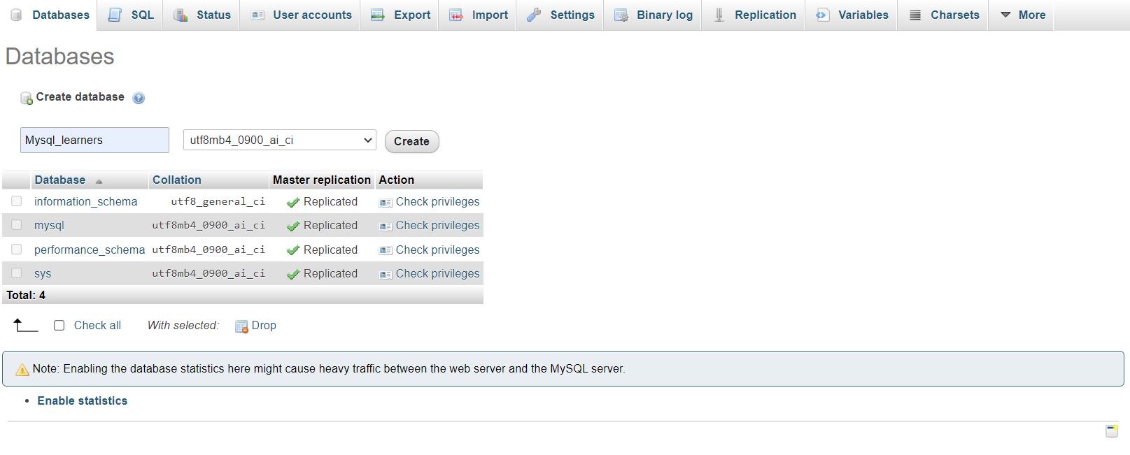

Load the dump files one by one into the database **Mysql_learners** by clicking the **Import** tab and choose the file.  
Click on **Go** button.

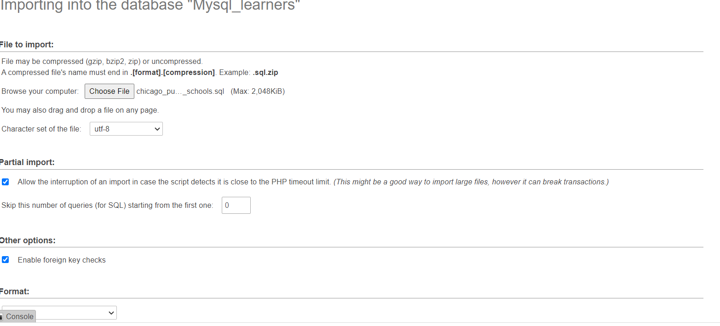

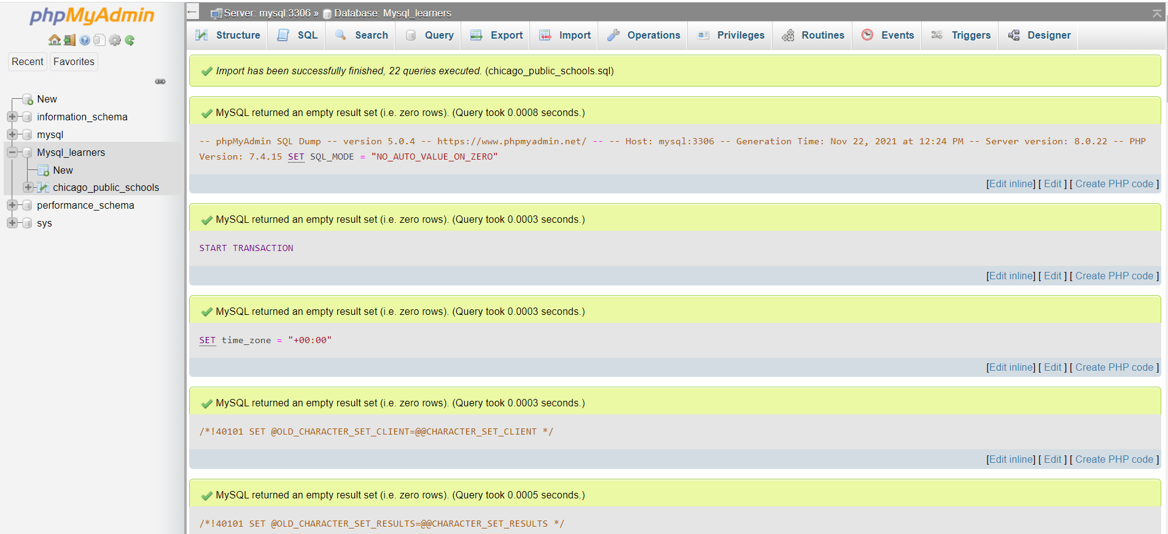

The tables are created and the data is loaded successfully. Repeat the same operation with the other 2 dump files to create and load the tables.

You will see a screen as below

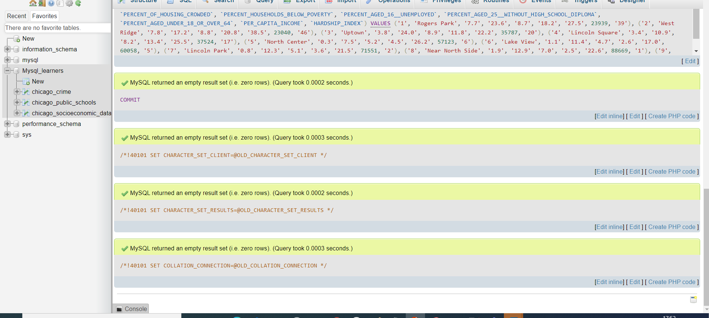

# Exercise

### Problem 1

##### List the case number, type of crime and community area for all crimes in community area number 18.

Hint 1Use tables chicago_public_schools and chicago_socioeconomic_data.Hint 2Use an inner join.Hint 3The column PRIMARY_TYPE contains the crime type.

### Problem 2

##### List all crimes that took place at a school. Include case number, crime type and community name.

Hint 1Use tables chicago_crime and chicago_socioeconomic_data.Hint 2Use a left join or a right join.Hint 3The column LOCATION_DESCRIPTION will help you find the crime location.

### Problem 3

##### For the communities of Oakland, Armour Square, Edgewater and CHICAGO list the associated community_area_numbers and the case_numbers.

Hint 1Use tables chicago_crime and chicago_socioeconomic_data.Hint 2Use the union operator with LEFT and RIGHT outer joins.Hint 3Use COMMUNITY_AREA_NUMBER from chicago_socioeconomic_data.

### Congratulations! You have completed this lab, and you are ready for the next topic.

# Author(s)

[Lakshmi Holla](https://www.linkedin.com/in/lakshmi-holla-b39062149/?utm_medium=Exinfluencer&utm_source=Exinfluencer&utm_content=000026UJ&utm_term=10006555&utm_id=NA-SkillsNetwork-Channel-SkillsNetworkCoursesIBMDeveloperSkillsNetworkDB0201ENSkillsNetwork20127838-2021-01-01)

[Malika Singla](https://www.linkedin.com/in/malika-goyal-04798622/?utm_medium=Exinfluencer&utm_source=Exinfluencer&utm_content=000026UJ&utm_term=10006555&utm_id=NA-SkillsNetwork-Channel-SkillsNetworkCoursesIBMDeveloperSkillsNetworkDB0201ENSkillsNetwork20127838-2021-01-01)

# Changelog

| **Date** | **Version** | **Changed by** | **Change Description** |
| --- | --- | --- | --- |
| 2023-05-04 | 0.4 | Rahul Jaideep | Updated Markdown file |
| 2022-05-11 | 0.3 | Appalabhaktula Hema | Updated hint |
| 2022-04-07 | 0.2 | Malika Singla | Updated screenshot |
| 2022-02-10 | 0.1 | Lakshmi Holla, Malika Singla | Initial Version |

### © IBM Corporation 2023. All rights reserved.